**Introduction**

A web app for interview preparation

**Design and Implementation**

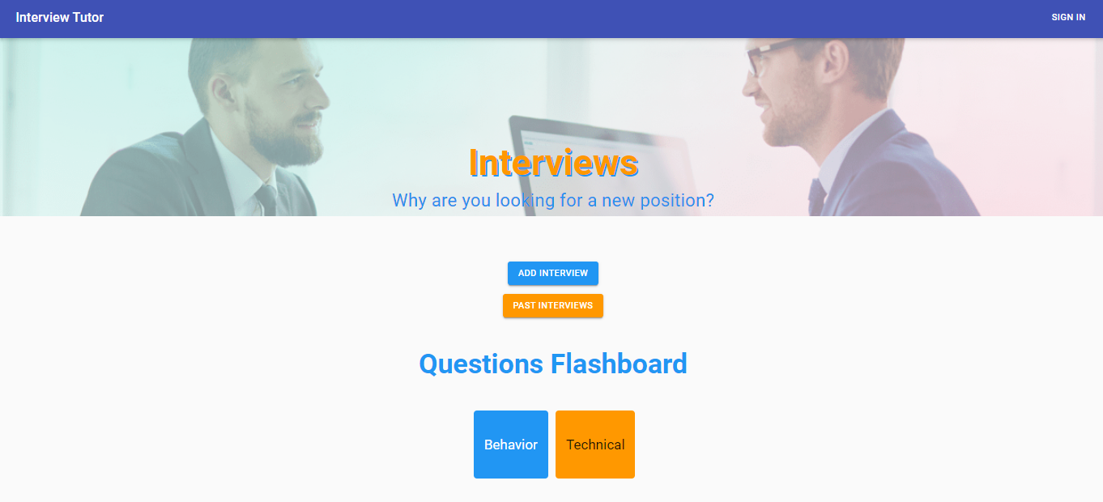

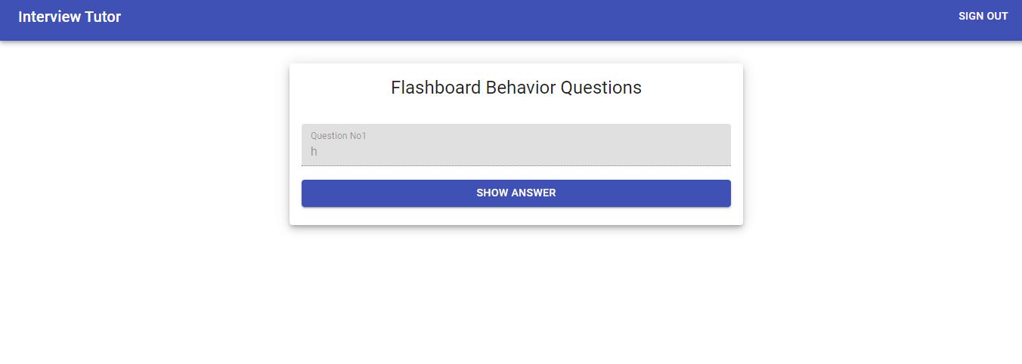

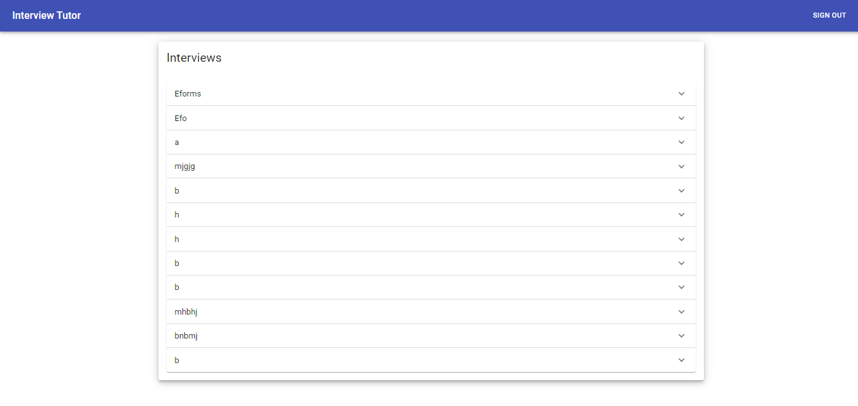

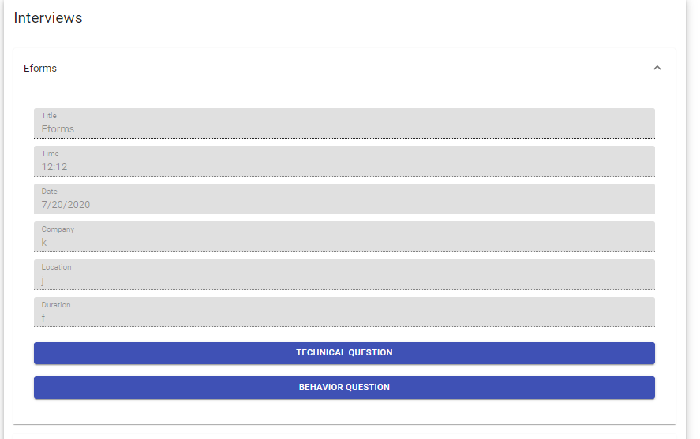

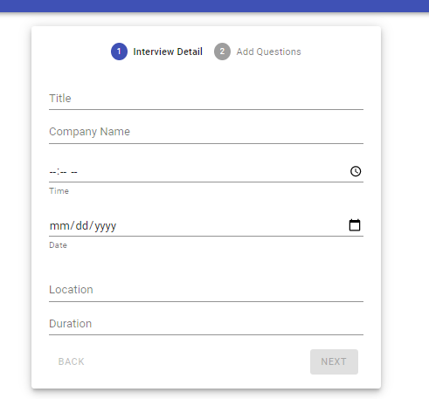

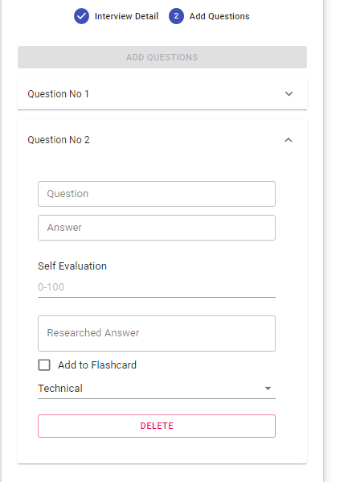

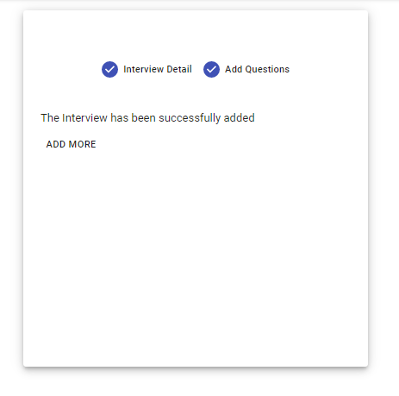

Library used :

"axios": "^0.19.2",

    "bcrypt": "^5.0.0",

    "body-parser": "^1.19.0",

    "cookie-parser": "^1.4.5",

    "cors": "^2.8.5",

    "datejs": "^1.0.0-rc3",

    "dotenv": "^8.2.0",

    "express": "^4.17.1",

    "formik": "^2.1.4",

    "http-errors": "^1.8.0",

    "mongoose": "^5.9.23",

    "morgan": "^1.10.0",

    "node-gyp": "^7.0.0",

    "node-sass": "^4.14.1",

    "nodemon": "^2.0.4",

    "path": "^0.12.7",

    "react": "^16.8.0",

    "react-dom": "^16.8.0",

    "react-helmet": "^6.1.0",

    "react-redux": "^7.2.0",

    "react-router-dom": "^5.2.0",

    "react-scripts": "3.4.1",

    "react-toastify": "^6.0.8",

    "redux": "^4.0.5",

    "redux-thunk": "^2.3.0",

    "use-state-with-callback": "^1.0.18",

    "yup": "^0.29.1"

**Conclusions**

* By this app user can add their personal interviews and revised it for further interview preparation
* One drawback right now is, user can only add interview but not delete the interview

**References**

<https://interview-tutor.herokuapp.com/>